**School: Banneker High School Program: 3DE/STEM**

**Teacher: *Mr. R. Williams* Subject/Grade: *Biology/Honors Biology/9th & 10th***

**Biology Summer Assignment**

**Section 1. Lab Safety**

**MULTIPLE CHOICE. Circle the best answer(s).**

1. If you spill an acid or a base on yourself, you should:

1. rinse with a neutralizing solution
2. ask your teacher what to do
3. immediately wash with soap and cool water and tell your teacher
4. do nothing unless you feel a burn or irritation

2. You may remove your goggles while in the lab room:

1. never
2. if no one is doing an experiment or washing glassware
3. if you are wearing glasses or contacts
4. anytime

**Section 2. Scientific Method**

List the scientific method in order:

**Section 3: Biology Vocabulary**

1. Abiotic factors-

2. Biotic Factors-

3. Biology-

4. Osmosis-

5. Diffusion-

6. Mitochondria-

7. Herbivore-

8. Carnivore-

9. Omnivore-

10. Eukaryotic-

11. Prokaryotic-

12. Mitosis-

13. Meiosis-

Section 4. Food chains

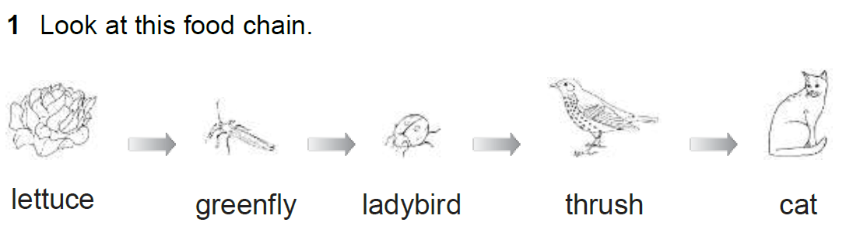

Look at this food chain.

lettuce greenfly ladybird thrush cat

**a** What does the arrow mean in a food chain?

**b** Name the producer in the food chain

**c** Name the third trophic level in the food chain.

**d** Name the tertiary consumer in the food chain.

**e** What is the ultimate source of energy that drives the food chain? ________

Section 5: Punnett Square

Complete the following squares.

