Early Western Christian Denominations
 | Roman Catholicism | Lutheranism | Calvinism | Anglicanism
Origins of the Denomination | Peter as first Pope? | -Founded by Mather Luther’s followers after his excommunication | Founded by John Calvin in Geneva, Switzerland | Founded by Henry VIII for Political Reasons (doesn’t want to share wealth and power with church)  Personal Reasons (Wants to divorce his first wife Catherine)
Beliefs about Sin and Salvation | Salvation comes from combination of faith, works, church intervention.  7 Sacraments  - Baptism  - Eucharist  - Confirmation  - Confession  - Marriage  - Ordination  - Unction | Cannot earn Salvation (it is God’s gift)  Accepted word of the Bible as truth  Only two sacraments  - Baptism  - Eucharist | Predestination (God already determined who was going to heaven)  Behave well to honor God  Strict Rules | Baptism washed away sin (like Catholics)  Justification of faith (Luther)  To get to heaven, believe in god, regret sins, and get mercy  People should have privacy
Beliefs about the Ultimate Source of Authority | Pope and clergy interpret the Bible that was written only in Latin. Others were not supposed to read it. | Bible was the only true source of authority | Bible was the only true source of authority  Made laws in society based on religion  You are punished by both the church and the law | Based beliefs on the Bible, Tradition, Reason.  Monarch was the head of the church
Rituals and Worship | High degree of ritual | Met in Churches  Holy Communion, singing, mass (Catholic)  Prayers were spoken in German | Services 5 times a week  Simple Church  Very Strict  2 Sacraments | High Church (Catholic)—much ritual  Low Church (Luther)—little ritual  Held in former Catholic Churches  2 Sacraments (5 sacramental rites)  English Bible
Community Life | Clergy may not marry. | Clergy may marry. | theocracy  Strict Society  Church can inspect homes  No dancing, etc.  Clergy can marry. | High Church = Wealthy  Low Church = Poor  People may choose how they worship  Often seen as a bridge between Roman Catholicism and Protestantism.  Clergy may marry.
Nature of the Eucharist | Transubstantiation: The belief that the bread and wine physically transform into the body and blood of Christ. The bread and wine cease to exist. | Consubstantiation: The belief that the bread and wine coexist with the body and blood of Christ. Christ’s body and blood are present, but so are the bread and wine. | Signal: the bread and wine become signals of Christ’s presence. | Consubstantiation: Christ’s Real Presence with the bread and wine.

Lutheranism

The first major Protestant sect was Lutheranism. Lutheranism began in Germany after Martin Luther was excommunicated by the Catholic Church in 1521.
Luther was a Catholic priest and scholar. He taught scripture and theology (the study of religion) at the University of Wittenberg. As he studied the Bible, Luther became troubled. He could not find a basis in the Bible for many Church teachings and practices. He was also upset about corruption in the Church, especially the sale of indulgences.
Luther tried to work out his differences with the Church. But after his views were condemned, he started the separate movement that became Lutheranism.
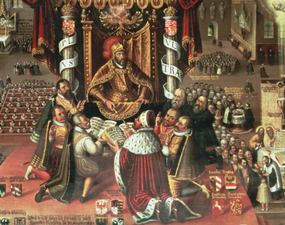
Beliefs About Sin and Salvation Luther and his followers disagreed with the Catholic Church about sin and salvation. Catholics believed that people earned salvation by following the teachings and practices of the Church. Taking part in the sacraments was essential. For example, the sacrament of baptism wiped away original sin. In Christian belief, this was the sinful condition passed on to all people by Adam, the first man created by God. Once they were baptized, people needed to pray, take the sacraments, follow rules laid down by the Church, and perform good works.
Lutherans did not believe that people could do anything to earn their salvation. Salvation, they said, was God’s gift, which people received in faith. People would be “justified,” or saved, if they sincerely believed in Jesus Christ, were sorry for their sins, and accepted the words of the Bible as truth. Luther called this “justification by faith.” Those who have faith perform good works and avoid sin because God commands them to, not in order to earn salvation.
Ultimate Source of Authority Lutherans rejected traditional sources of religious authority, such as Church councils and the pope. They believed that the Bible was the only true source of religious guidance. Reading the Bible was the only way to learn how to lead a good life and gain faith in God. Lutherans published the Bible in several languages so that people could read it for themselves.
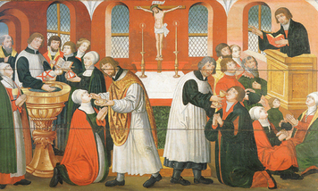
Rituals and Worship Lutheran services combined Catholic practices with new Lutheran ones. Lutherans met in church buildings that had originally been Catholic. Like Catholics, they used an altar, candles, and a crucifix, which represented the crucifixion of Jesus.
Lutheran services resembled the Catholic mass in several ways. The services included Holy Communion, the Christian ritual of sharing bread and wine to commemorate the last meal Jesus shared with his disciples before his death. Lutheran services also included Bible readings and a sermon, in which clergy explained the day’s lesson from the Bible.Like Catholics, Lutherans sang hymns. Luther wrote hymns for his followers. He used German words and often set hymns to popular tunes so everyone could learn them more easily.
Other parts of Lutheran worship were different from Catholic practice. Prayers were written and spoken in German, not in Latin, so that everyone could take part. Instead of having seven sacraments, Lutherans had just two: baptism and Communion. Luther believed that they were the only sacraments clearly named in the Bible.
Community Life Luther gave his followers certain rules for how to live. Over time, he preached less about the Bible. He began to place greater importance on discipline and strong families. He said that fathers should teach their children religion by having them pray before meals and before bed. “Unless they [pray],” he said, “they should be given neither food nor drink.” He also thought that women should get married and give birth to as many children as possible. He believed that these rules would help to strengthen Lutheran communities.
Unlike Catholic priests, Lutheran ministers, or members of the clergy, were free to marry. Luther himself married a former nun.

Calvinism

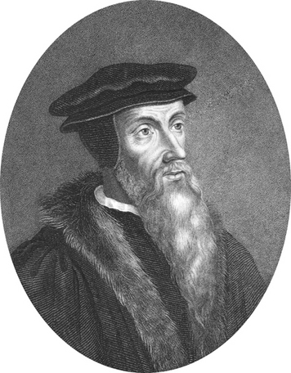
Calvinism was founded by John Calvin, a French humanist who did his most influential work in Geneva, Switzerland. In 1541, Calvin took over the leadership of the reform movement in Geneva.
Beliefs About Sin and Salvation Calvinists agreed with Lutherans that people depended entirely on God to be saved. No one deserved salvation, and no one could “force” God to grant it by doing good works. Instead, God chose certain people, the “elect,” to be saved and to enjoy eternal life. Religious faith and salvation were God’s gifts to the elect. Everyone else was doomed to spend eternity in hell.
Calvin maintained that God knew from the beginning of time who would be saved and who would be condemned. This idea is called predestination. There was nothing people could do to change their destiny. Everything, Calvin said, is under God’s control.
Calvinists believed that the elect could be known by their actions. They believed that the world was full of opportunities to sin. But only people who were destined not to be saved would sin. Good behavior showed that a person was an elect destined for heaven. The reason for good behavior was to honor God, not to “buy” one’s salvation.
Calvinists had many strict rules defining good behavior. For example, singing, dancing, playing cards, and wearing fancy clothing were all forbidden. Many people followed these rules to show that they were saved.
Ultimate Source of Authority Like Lutherans, Calvinists thought that the Bible was the only true source of religious guidance. Part of the task of church leaders was to interpret the Bible and make laws from it. Calvinists believed that all of life should be lived according to God’s law .Consequently, in a Calvinist state, religious rules also became laws for the government. Anyone who sinned was also committing a crime. A lawbreaker was punished first by Calvinist clergy and then by the local court system. Sins such as blasphemy (showing disrespect to God) were punished as serious crimes.
Rituals and Worship Calvinist churchgoers attended services up to five times a week. Services included sermons that lasted for hours. The sermons explained how to live according to the Bible.
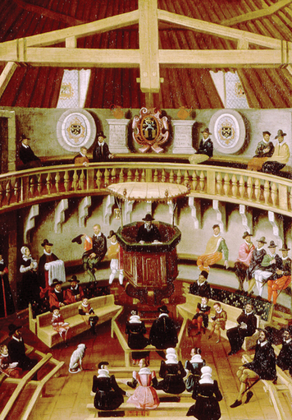
Calvinist church buildings showed Calvin’s belief in simplicity. Churches were paneled in plain wood. People sat on long wooden benches. There were no paintings, statues, or stained glass windows. The minister preached from a pulpit in the middle of the room. Men sat on one side, and women and children sat on the other side. Children had to be ready to answer questions from the minister at a moment’s notice. Failure to answer correctly would bring them shame or even punishment.
Like Lutherans, Calvinists used only the two sacraments they found in the Bible: baptism and Communion. Calvinists were not allowed to sing any words except those in the Bible. At services, they sang verses from the Bible set to popular tunes. Some Bible songs had new melodies written for them.
Community Life Calvinists believed that each community should be a theocracy, or a state governed by God through religious leaders. Calvinists had a duty to try to establish communities in which church and state were united.
Calvinist communities had strict laws based on the Bible. Parents could name babies only certain names from the Bible. Guests at local inns were not allowed to swear, dance, play cards, or insult anyone at the inn. Innkeepers had to report anyone who broke these rules. The same rules applied to people in their homes. Church leaders could inspect homes yearly to see whether families were living by the strict Calvinist laws. Offenders were punished severely. Some were even banished.

Anglicanism

Anglicanism was founded in 1534 by King Henry VIII in England. Henry was not a religious reformer like Martin Luther or John Calvin. Instead, he broke away from the Catholic Church for political and personal reasons.

Politically, Henry did not want to share either his power or his kingdom’s wealth with the Church. Personally, he wanted to get a divorce so that he could marry another woman, Anne Boleyn. He wanted a male heir, and he and his first wife, Katherine of Aragon, failed to have a male child.
When the pope refused to grant permission for a divorce, Henry took matters into his own hands. He compelled Parliament, England’s lawmaking body, to declare him the head of the English church. So began the Church of England, or Anglican Church, with the monarch at its head.
Under Henry, the Church of England still greatly resembled the Catholic Church. Over time, however, it blended elements of Catholicism and Protestantism.
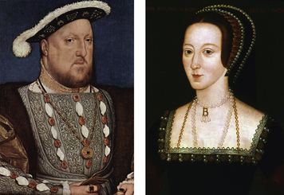
Beliefs About Sin and Salvation Anglican beliefs had much in common with the beliefs of the Catholic Church. Like Catholics, Anglicans believed that baptism washed away original sin. Anglicans, however, were also influenced by Protestant ideas. Unlike Catholics, they accepted Luther’s idea of justification by faith. To go to heaven, people needed only to believe in God, regret their sins, and receive God’s mercy.
Later, Anglicans believed that people should have privacy in how they practiced religion. It was up to individuals to figure out how to live by their religious beliefs.
Ultimate Source of Authority Anglicans based their beliefs on the Bible as viewed through the two lenses of tradition and reason. The highest-ranking bishop in England, the Archbishop of Canterbury, helped the monarch with this task. Local clergy and churchgoers could interpret Church teachings in their own ways, as long as they were loyal to the monarch.
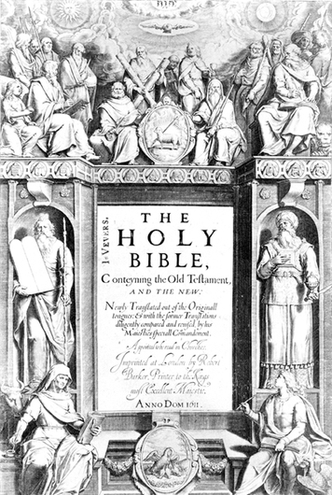
Rituals and Worship Anglican services were similar to both Roman Catholic and Lutheran services. Two versions of the Anglican Church service developed. The High Church service was much like the Catholic mass, and very formal. The Low Church service was similar to the Lutheran service.
Anglican services were held in former Catholic Church buildings. Like other Protestant groups, Anglicans used only two sacraments: baptism and Communion, but as they were a bridge with Roman Catholicism, the 5 others became sacramental rites. English slowly replaced Latin in Anglican services. Under Henry’s son, King Edward VI, an official prayer book, the Book of Common Prayer, was published. It provided English-language prayers for services and morning and evening prayers. It also expressed the basic ideas of Anglican doctrine. In the early 1600s, King James I had a committee of scholars prepare a new English translation of the Bible, known as the Authorized Version, or the King James Version.
Community Life Anglican communities were not all alike. High Church communities, however, were made up mostly of wealthy people. Low Church communities were usually made up of middle-class and working-class people.
Henry VIII’s daughter, Queen Elizabeth I, said that no one should be forced to believe or practice a particular kind of Anglicanism. People could choose how to worship as long as they obeyed the laws of England and were loyal to the monarch. Heresy ceased to be a crime. However, citizens had to take care not to attack the monarch or the Anglican Church’s place as the official Church of England.

