Algebra 1 Summer Assignment

2019-2020

Due: 1st Day of School print & complete or write answers on separate sheet of paper

(Part one): Coordinate plane Review - Label the coordinate plane with the words in the word bank.
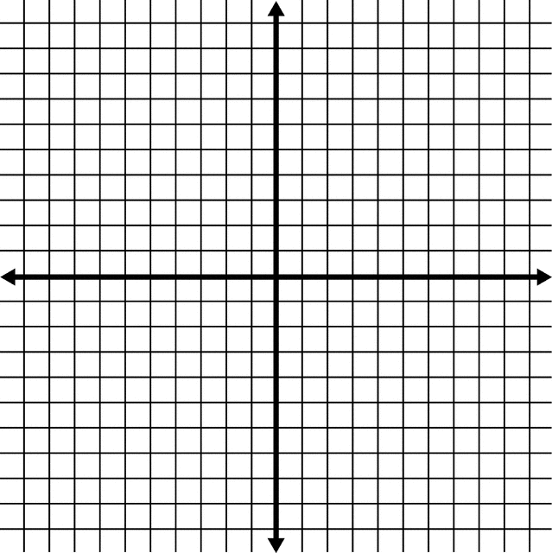
Word Bank
x-axis
y-axis
quadrant i
quadrant ii
quadrant iii
quadrant iv
origin
x-intercept
y-intercept

(Part two): One-Step Equations - Using inverse operations, solve the following one-step equations.

- $x-7=10$

- $x+4=6$

- $x-8=-2$

- $x+2=-9$

- $\frac{x}{3}=6$

- $4x=8$

(Part three): Area - Find the area of each rectangle. **Hint: Area = base x height

5 in

5 in

5 ft

4 yd

12 yd

6 m
9 ft

(Part four): Perimeter - Find the perimeter of each shape.

5 in

5 in
5 in

5 in
9 ft

5 ft
5 ft

4 yd

12 yd

6 m
9 ft

(Part five): Slope – Find the slope of the line given 2 ordered pairs and match to the appropriate graph.
$$Slope=\frac{y_{2}-y_{1}}{x_{2}-x_{1}}$$
Graph A
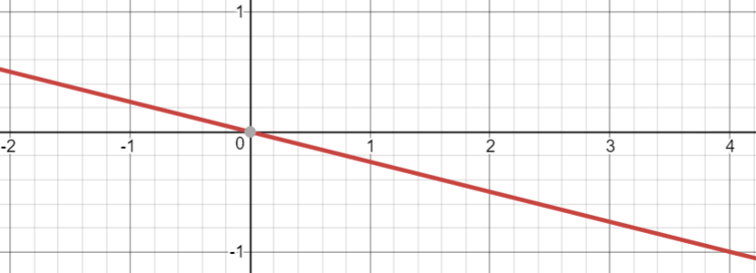
Graph B
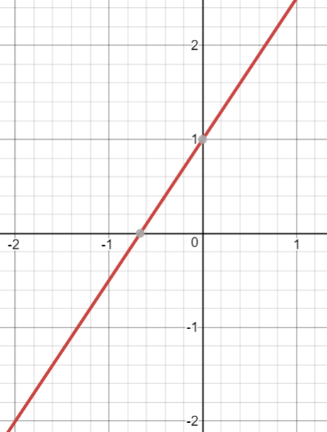
Graph C
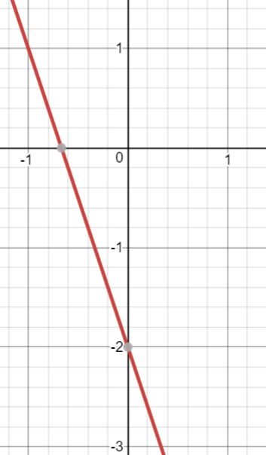
Graph D
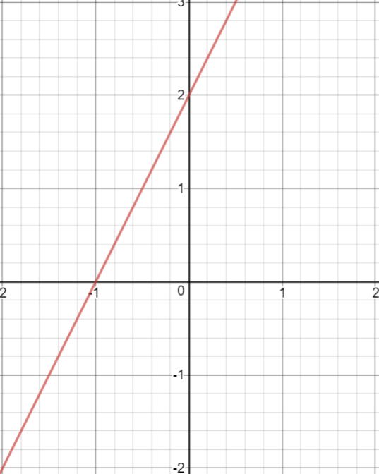

- (0,2) and (-1,0) matches Graph ______

- (0,0) and (4,-1) matches Graph ______

- (-2,-2) and (0,1) matches Graph ______

- (-1,1) and (0,-2) matches Graph ______

